**Customer Satisfaction Analysis - Manufacturing Sector**

GOKULNATH K & E24755

**Overview**

Customer satisfaction analysis in the manufacturing sector involves measuring client feedback on product quality, delivery timelines, and after-sales service. Data analytics is used to assess patterns in complaints, survey responses, and product returns, identifying areas for improvement. Key metrics include Net Promoter Score (NPS), customer retention rates, and service-level agreement (SLA) adherence. By leveraging insights, manufacturers can enhance product quality, optimize processes, and improve overall customer experience.

**Objective**

1. Improve Product Quality: Identify patterns in customer feedback to enhance product design and reduce defects.
2. Enhance Customer Retention: Analyze satisfaction scores to boost loyalty and minimize churn.
3. Optimize Delivery and Service: Use data insights to improve delivery timelines and after-sales support.
4. Identify Key Satisfaction Drivers: Determine which factors (quality, pricing, service) most influence customer satisfaction.
5. Monitor Performance Over Time: Track satisfaction trends to gauge long-term performance and adjust strategies.

**Assigned Task(s)**

* Customer Satisfaction Analysis - Manufacturing Sector

**Task Details**

* **Task 28 :** Customer satisfaction analysis in the manufacturing sector uses data analytics to evaluate feedback on product quality, delivery, and service. This helps identify areas for improvement and enhance overall customer experience.
* **Status:** Completed.
* **Details:**

1. Data Visualization: Utilizes Seaborn’s barplot() to illustrate the relationship between product quality issues and average delivery time.
2. Customization: Sets figure size, adds descriptive title, and labels for clarity.
3. Count Annotation: Displays average delivery times on top of bars using ax.annotate(), enhancing data visibility.
4. Data Interpretation: Analyzes how quality issues impact delivery efficiency (0 = No issues, 1 = Yes).
5. Color Palette: Employs the viridis palette for improved visual appeal.
6. Insights: Identifies areas for improvement in product quality and delivery processes to boost customer satisfaction.

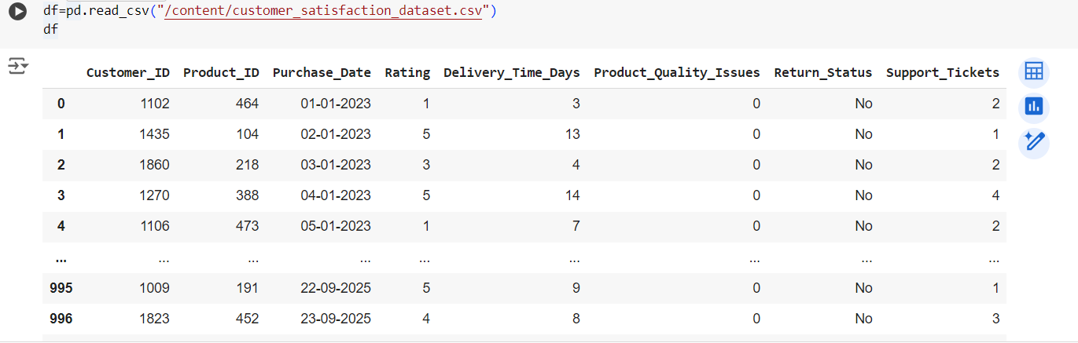

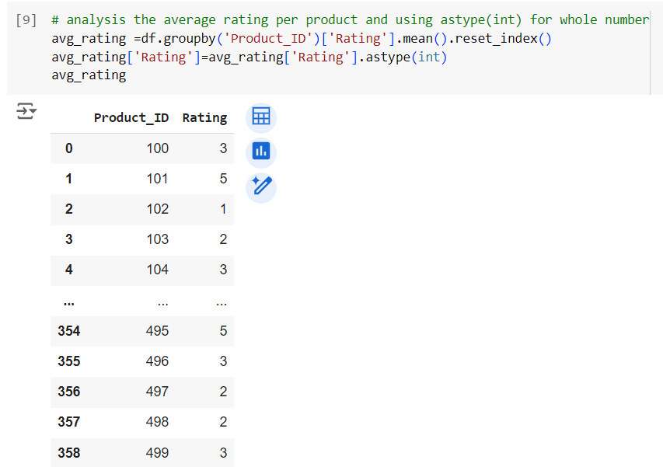

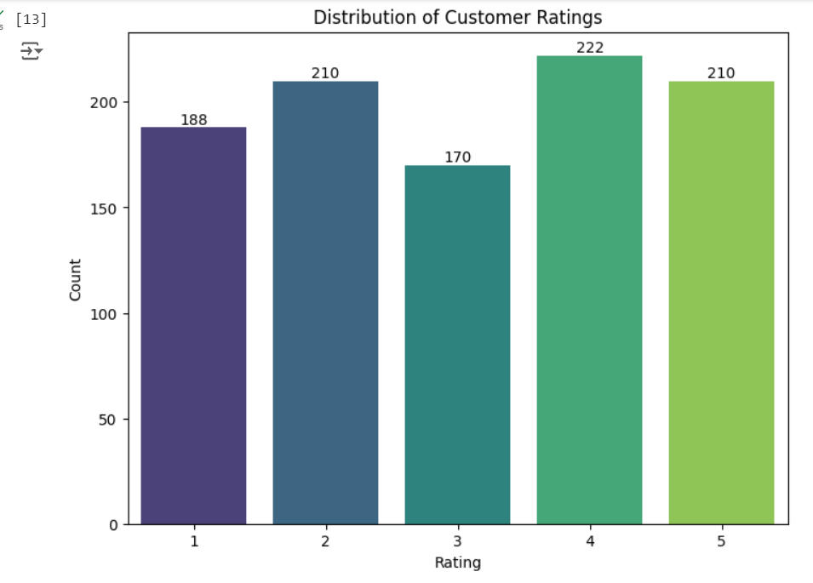

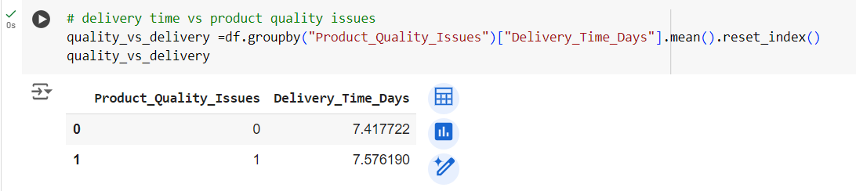

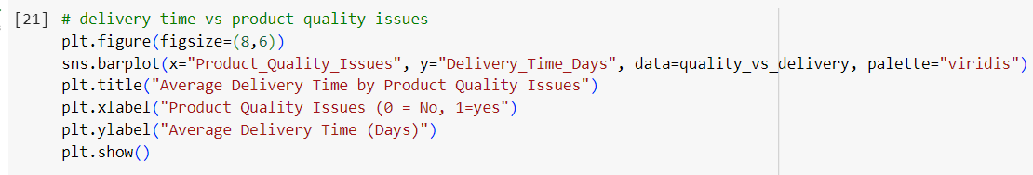

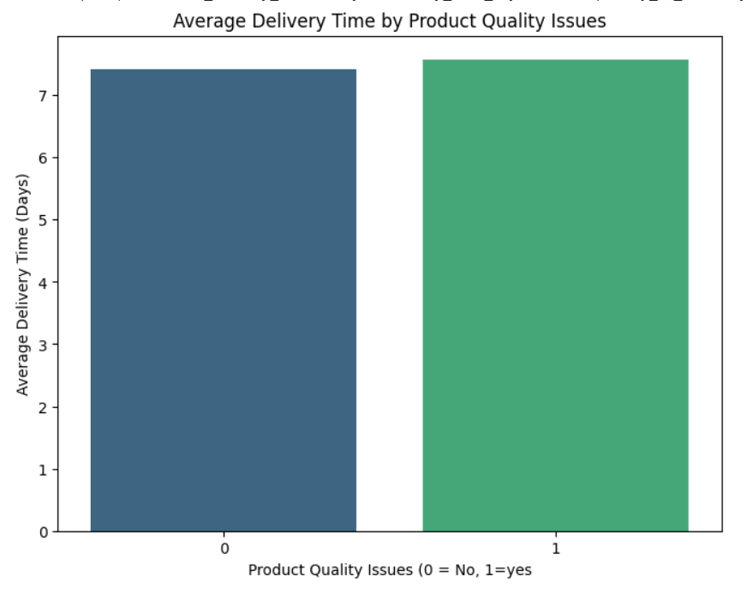

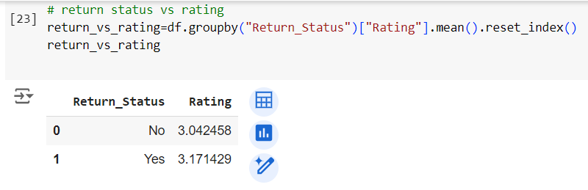

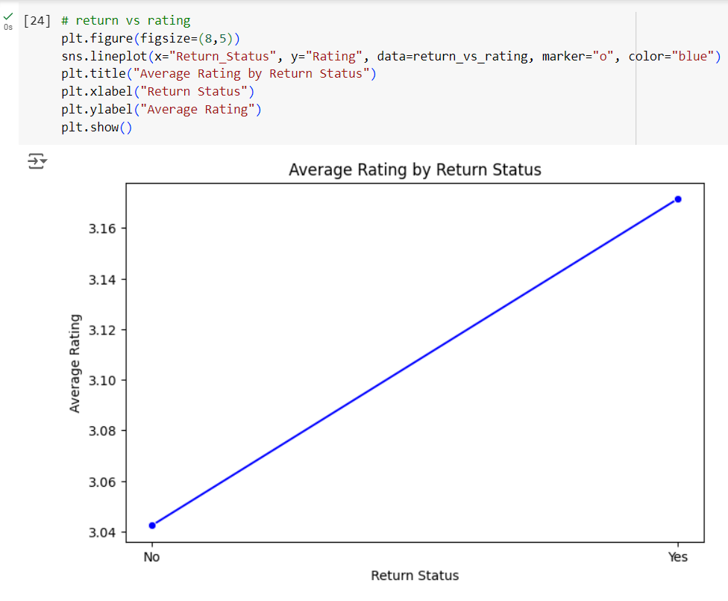

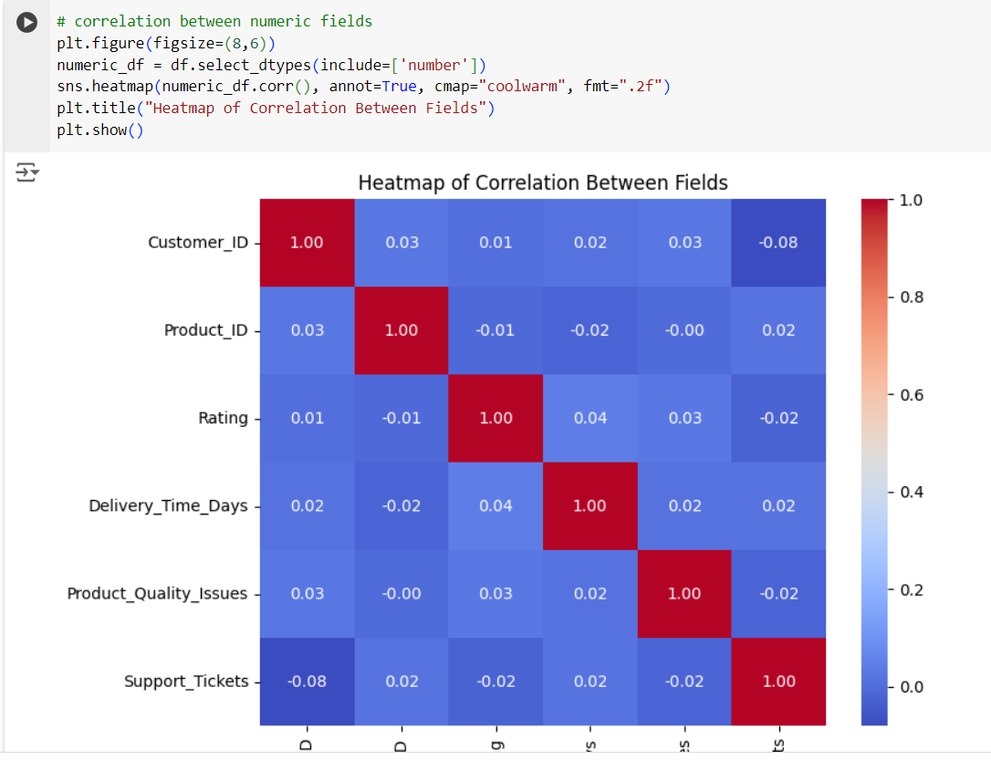

**Progress**

* **Accomplishments:**

1. Data Collection: Successfully gathered and cleaned a dataset containing customer feedback, product quality issues, and delivery times.
2. Descriptive Analysis: Conducted descriptive statistical analysis to summarize customer satisfaction metrics, including average ratings and delivery times.
3. Visualization: Created visualizations using Seaborn and Matplotlib to illustrate the distribution of customer ratings and the impact of product quality on delivery times.
4. Correlation Analysis: Analyzed the correlation between product quality issues and customer satisfaction ratings, identifying key factors affecting customer perceptions.
5. Insights Generation: Developed actionable insights to improve product quality and delivery performance, aiming to enhance overall customer satisfaction.

* **Metrics:**

1. Customer Satisfaction Index: A composite score derived from customer ratings, reflecting overall satisfaction.
2. Average Rating by Product: The mean rating for each product, helping to identify top-performing items.
3. Delivery Time Analysis: Average delivery time based on product quality issues, providing insight into operational efficiency.
4. Return Status Impact: Average rating comparison between returned and non-returned products, indicating product quality and customer experience.
5. Feedback Volume: Count of ratings per category (e.g., rating levels), assessing customer engagement and sentiment distribution.
6. Correlation Analysis: Correlation coefficients between numeric fields, helping identify relationships (e.g., between delivery time and ratings).
7. Missing Values: Count of missing values in the dataset, important for data quality assessment and handling before analysis.
8. Visualization Insights: Visual representation of data trends (distributions, averages) that facilitate easy interpretation of results.

**Challenges and Solutions**

* **Challenges Faced:**

1. Incomplete or inaccurate data can lead to misleading analyses.
2. Combining data from multiple sources can be complex.
3. Stakeholders may misinterpret visualizations or statistical outputs.

* **Solutions Implemented:**

1. Implement robust data validation checks and cleansing processes.
2. Use ETL (Extract, Transform, Load) processes to standardize and integrate data efficiently.
3. Provide clear documentation and training on data interpretation and visualization techniques.

**Next Steps**

* **Upcoming Tasks:** To face upcoming tasks in the manufacturing sector, focus on advanced analytics, data management, automation, real-time monitoring.
* **Goals:** Regularly monitor my progress towards my goals, adjusting my plans as needed.

**Conclusion**

* **Summary:** Customer satisfaction analysis in the manufacturing sector is vital for enhancing product quality and service delivery, which directly impacts profitability. By leveraging data analytics, manufacturers can identify customer expectations, track satisfaction levels, Ratings and make informed decisions for continuous improvement. Ultimately, satisfied customers contribute to long-term business success and loyalty in a competitive landscape.
* **Acknowledgments:** Thank you all for your attention and engagement, I appreciate your interest in the Customer Satisfaction analysis.